**Steps to navigate and use Survey Form App**

* Once installation of package is done, Login into salesforce org, click on App menu grid on top left corner

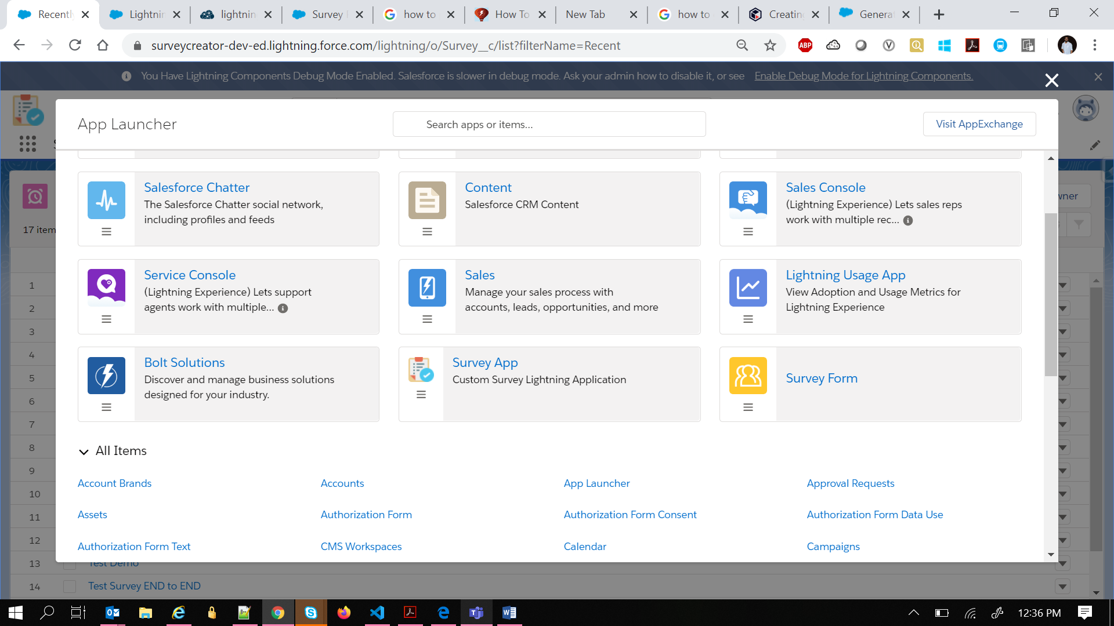

* Click on “Survey App”

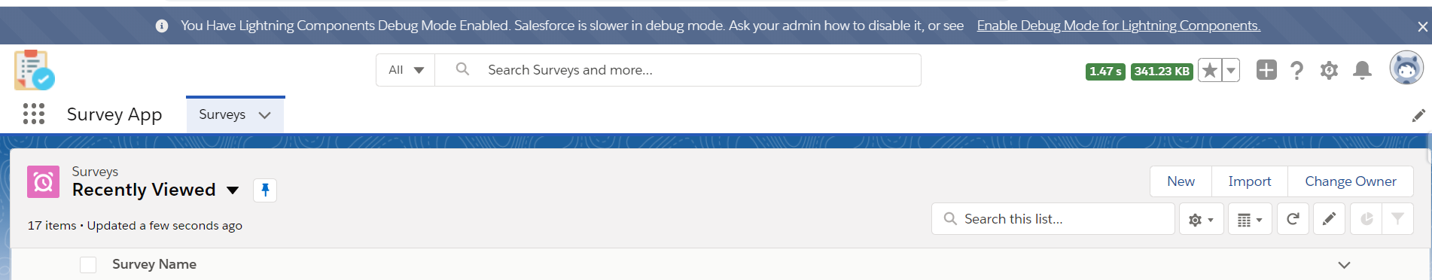

* Click on New to create a survey

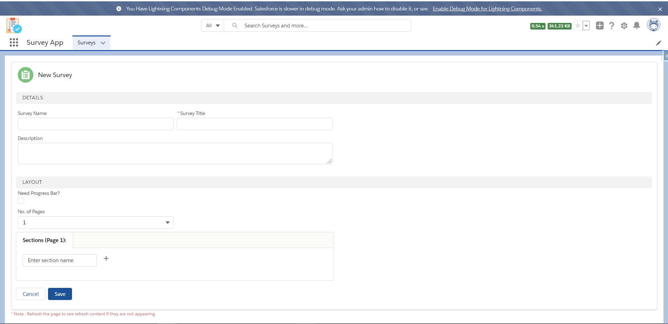

* Fill in the fields for survey details (click on + to add sections for respective pages)

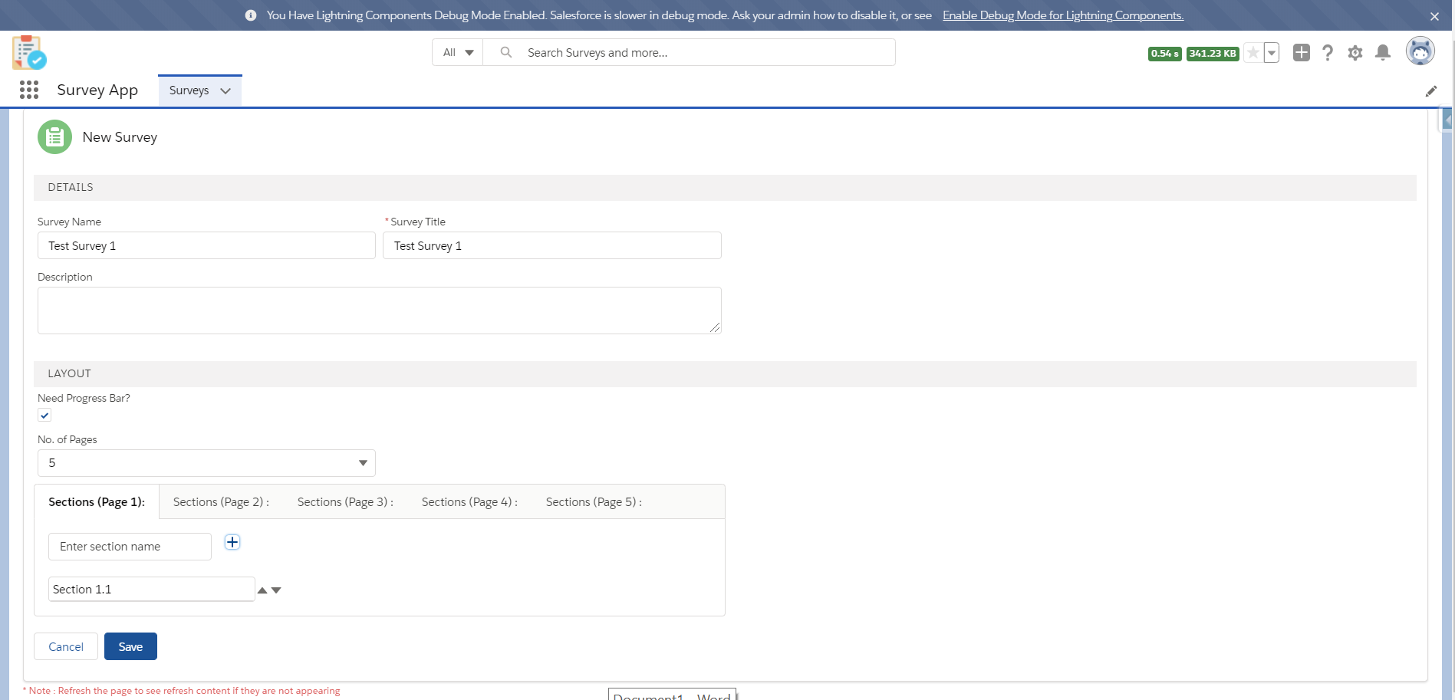

* Click on save once all fields are filled

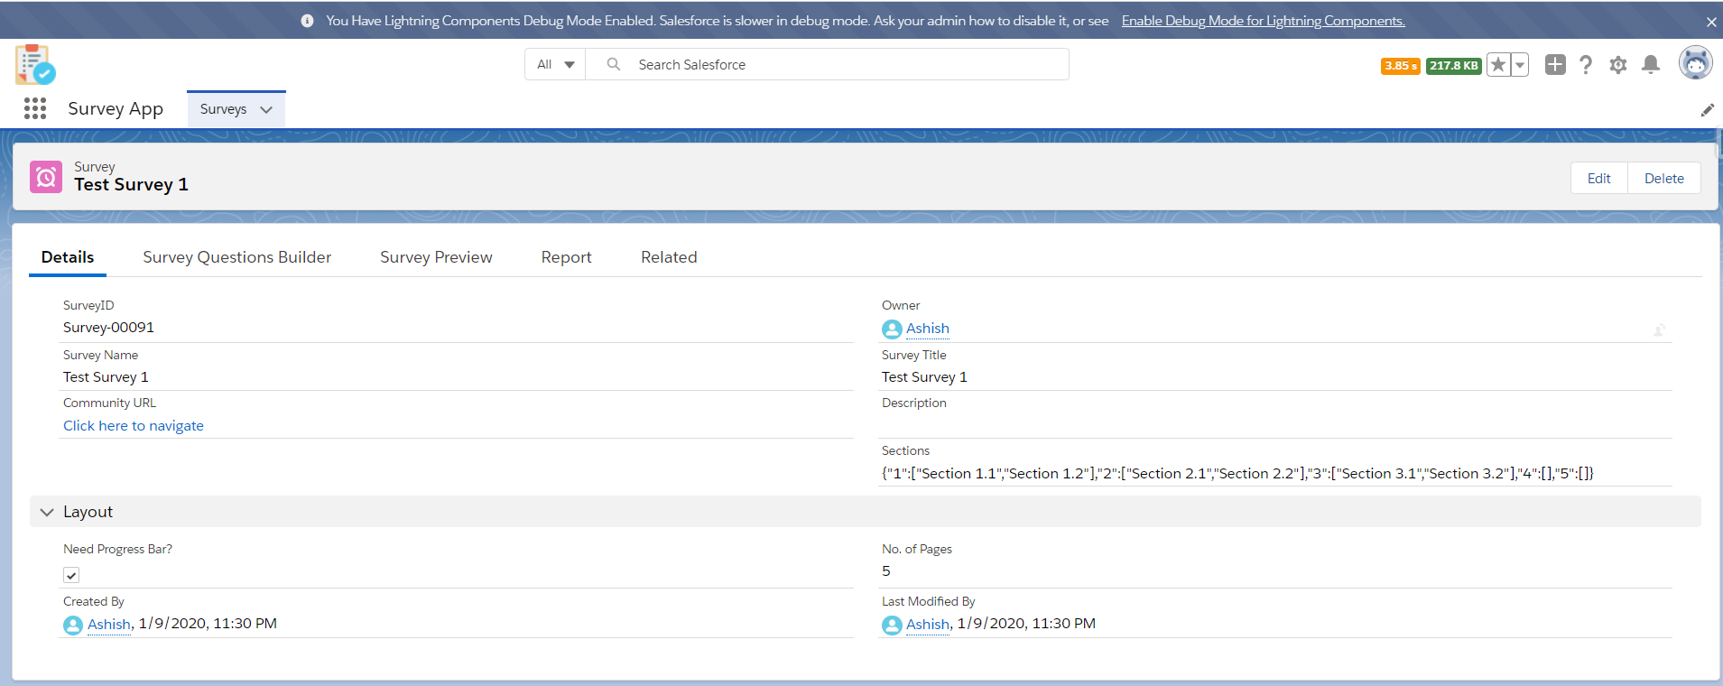

* Click on Survey Question Builder to add questions

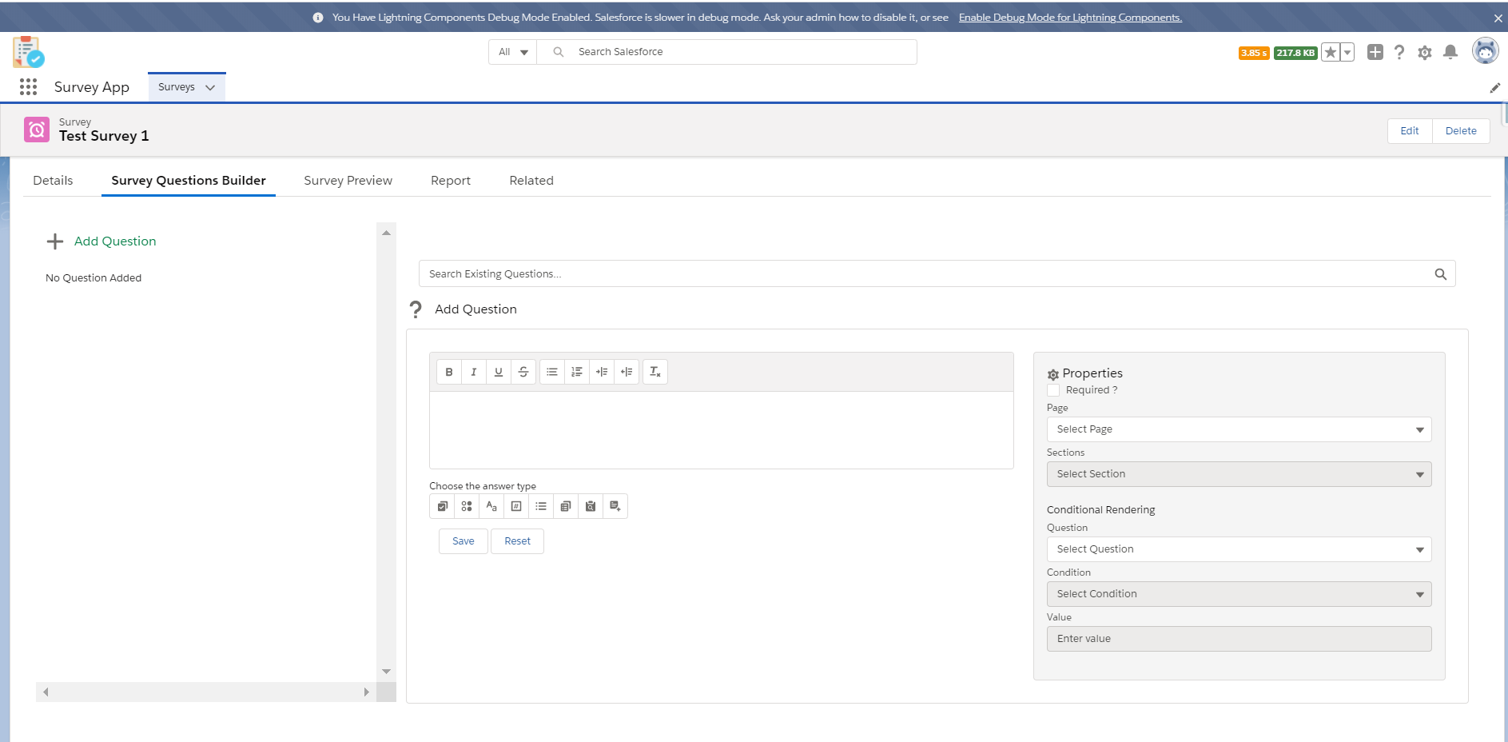

* Click on Add question to add question or by using Search existing question functionality, you can search question and add that to survey and fill the details
* On Text Area, Type the question
* Choose Answer options based on datatype for the question
* On Properties, fill the question properties such as which page, section and conditional rendering (Only available for Checkbox and Radio type)

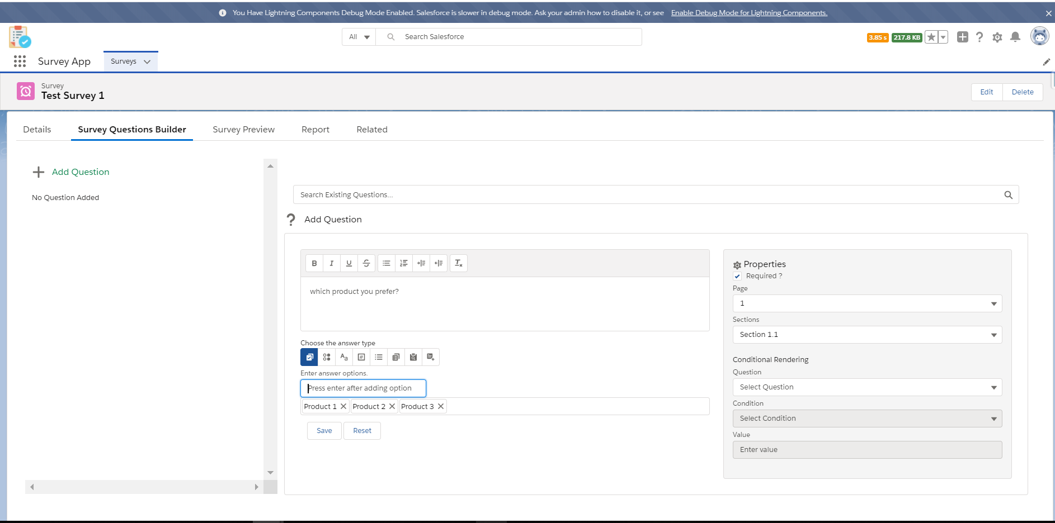

* Click on save to save question, and you will be able to see the same on left side panel. Below screenshot shows conditional rendering functionality as well

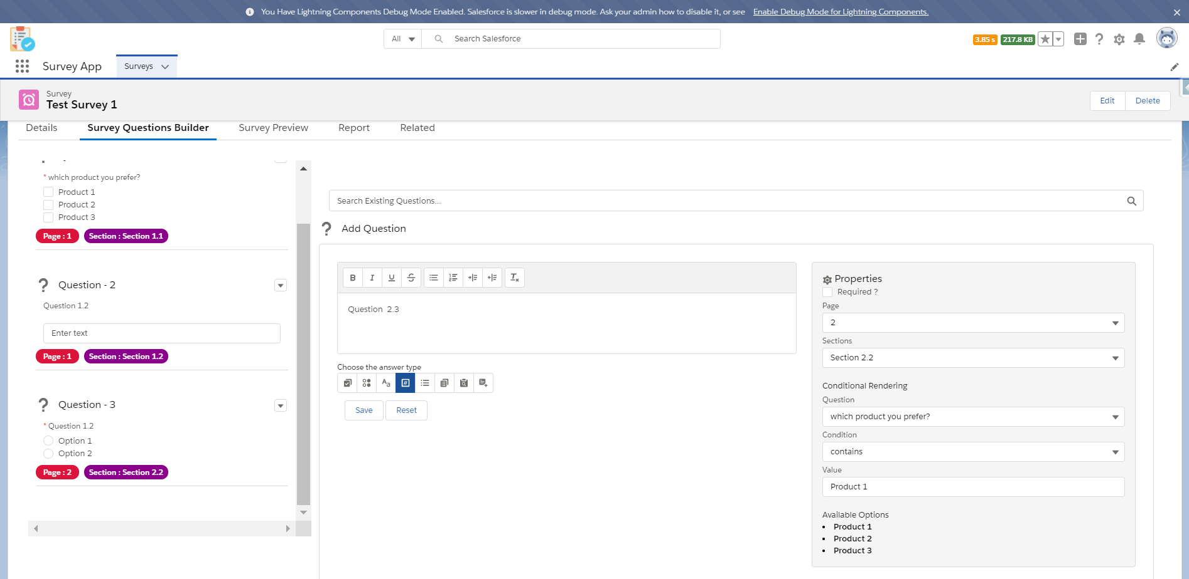

* To Preview the questions, refresh the page (to fetch latest details) and click on Survey Preview Tab

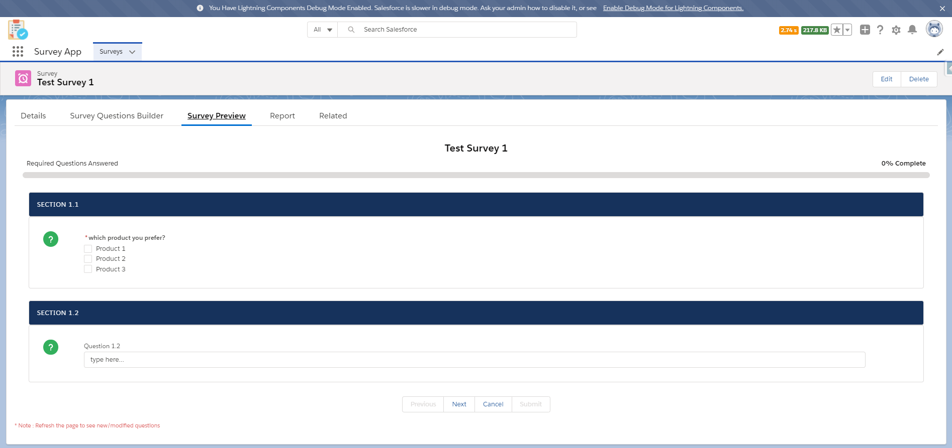

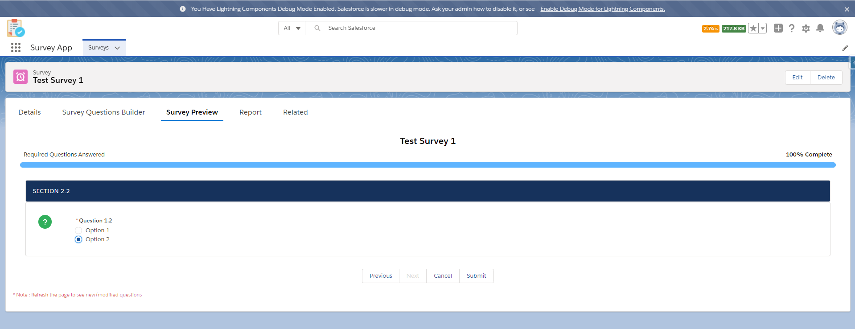

* Click on Next (Once all the required questions are answered, submit will be enabled. If no required questions, then on last page submit will be enabled.
* If page does not have any question, that page won’t be shown.
* Based on condition rendering Questions will be framed and shown/Hidden
* Click on submit once done.

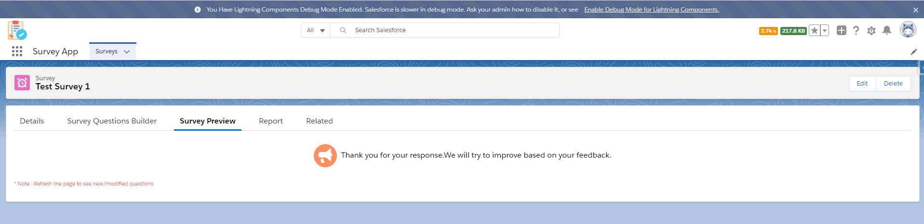

* On submit, the data will be shown on Related Tab, under survey response (with submitter details in JSON format)

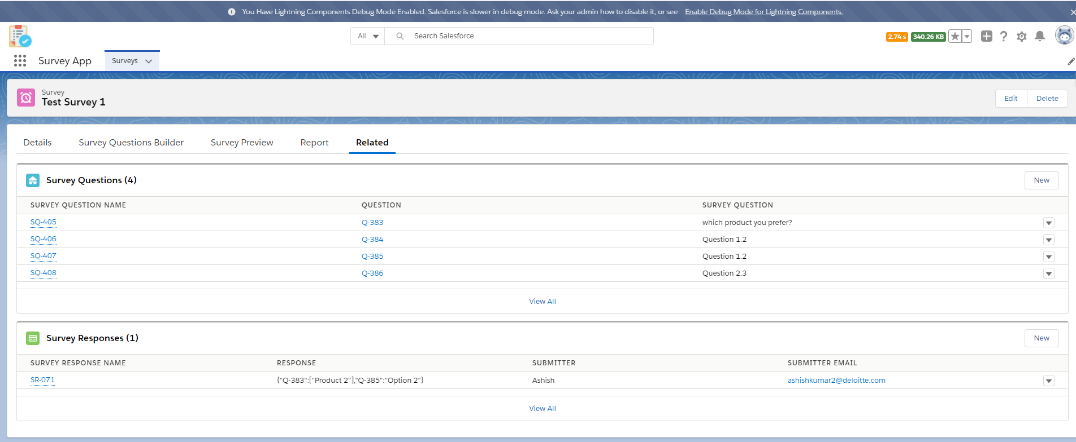

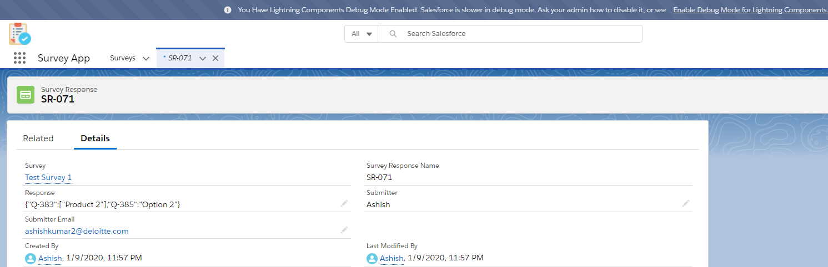

* Any exceptions related to DML operations will be stored in “Survey Error Log” object